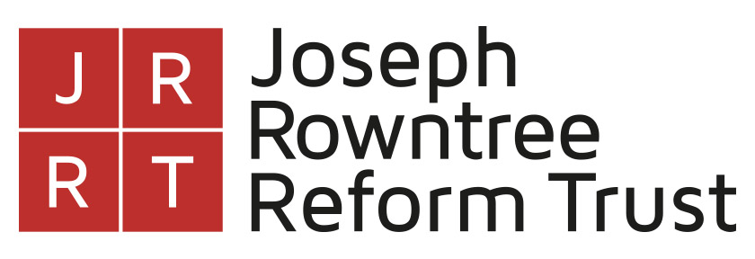

STRICTLY CONFIDENTIAL

DIVERSITY MONITORING QUESTIONNAIRE

Please complete both pages of this form and return with your application to: recruitment@jrrt.org.uk

These forms are anonymised and kept separately from your application.

We are collecting this data to inform and monitor our recruitment processes.

Disability:
Do you consider yourself to have a disability? This is defined by the Equality Act 2010 as a physical or mental impairment, which has a substantial and long-term adverse effect on your ability to carry out normal day-to-day duties.

Do you consider yourself to have a disability?
Yes
No
Prefer not to disclose

If you have answered ‘Yes’ to this question and wish to tell us of any adjustments that you may require, either to carry out the role or to participate in the selection process, please email details to recruitment@jrrt.org.uk

I identify my gender as:

Male

Female

Trans

_________________________________________ (fill in the blank)

Prefer not to disclose

Sexuality:
LGBTQ+
Heterosexual
Prefer not to disclose

What is your ethnic group?
Categories listed are those used in the census in England and Wales.

White:
English/Welsh/Scottish/Northern Irish/British
Irish
Gypsy or Irish Traveller
Roma
Any other White background

Mixed/multiple ethnic groups:
White and Black Caribbean
White and Black African
White and Asian
Any other Mixed/multiple ethnic background

Asian/Asian British:
Indian
Pakistani
Bangladeshi
Chinese
Any other Asian background

Black/African/Caribbean/Black British:
African
Caribbean
Any other Black/African/Caribbean background

Other ethnic group:
Arab
Any other ethnic group _____________________________________________

Prefer not to disclose

